Fluke Spring Deals; Buy One, Get One Free - 2025
Short T&Cs
Get a Fluke tool, when you make a purchase of at least £150.*
How to receive your tool from Fluke:
- Spend at least £150. (excluding VAT) or more on any qualified Fluke product(s) between February 17, 2025 and July 31, 2025.
- End-user customers residing in mainland European Union, United Kingdom, Switzerland, Norway, Sweden, Finland, Albania, Bosnia-Herzegovina, Iceland, Macedonia, and Serbia (excluding Canary Islands, Ukraine, and any country to which EU or US trade sanctions currently apply) (“Program Territory”) are eligible to participate in this promotion. Purchases must be made from an authorised Fluke distributor in the country of the customer’s residence, which is in the Program Territory.
- Proof of sale in the form of a single receipt or invoice is required. Packing slips, purchase orders/order confirmations are not acceptable as proof of purchase.
- Only qualifying Fluke products are eligible for this promotion.
- For online purchases, proof of delivery that indicates the delivery carrier, delivery date and electronic tracking number is required.
- Redeem your gift online! Visit: www.fluke.co.uk/freegift
- Receive and enjoy your new Fluke tool!
*Additional terms and conditions apply. By participating in this promotion, you agree to the terms and conditions. Please refer to the complete terms and conditions at www.fluke.co.uk/freegift

Terms and Conditions

- Overview. Under this Fluke Spring Deals; Buy One, Get One Free - 2025 program (the “Program” or “Promotion”), during the period February 17, 2025 and July 31, 2025 (the “Program Period”), get a Fluke gift of your choice (“Gift”) when you purchase a qualifying Fluke product (“Qualifying Purchase”) as detailed below, from an authorized distributor in mainland European Union, United Kingdom, Switzerland, Norway, Sweden, Finland, Albania, Bosnia-Herzegovina, Iceland, North Macedonia, and Serbia (excluding Canary Islands, Ukraine, and any country to which EU or US trade sanctions currently apply) (“Program Territory”). To make a Qualifying Purchase, contact Fluke Europe B.V. (“Sponsor”) directly or find an authorized distributor listed here.

Each Qualifying Purchase must be made during the Program Period, as shown by the date of purchase on the customer’s invoice/receipt. The Promotion is only valid on purchase(s) made during the Program Period. The offer available under the Program may not be combined with any other offer or redeemed for alternate products, services, cash, or credits except as expressly authorized in these terms and conditions.

- Eligibility. The Promotion is void where prohibited by law and open only to customers based in the Program Territory.

If you make a Qualifying Purchase specified in your gift request for or on behalf of your employer, then you agree to promptly deliver any gift awarded under the Program to your employer, and to provide Sponsor evidence of such delivery upon request. In addition, you are solely responsible for complying with your company’s policies regarding acceptance of gifts and participation in promotions like this Program.

Employees, directors and officers of Sponsor, its parent companies, affiliated companies, subsidiaries, (sub-)distributors, agents, resellers, representatives, public relations, advertising, promotion and fulfillment agencies, professional advisors, consultants, website providers, web masters and those persons’ immediate families (parents, siblings, children and spouse, wherever they may live) and persons living in the same household (whether related or not) are not eligible to participate in the Promotion. This Promotion is also not applicable to healthcare professionals, being (a) individuals (or entities) involved in the provision of health care services to patients, or (b) individuals (or entities) who purchase, lease, recommend, use, arrange for the purchase or lease of, or prescribe Sponsor’s medical products or services on behalf of health care professionals, including physicians’ purchasing agents, physicians’ practice managers and management within medical group purchasing organizations. Further, no employees, officers, directors, or representatives or agents of Sponsor’s distributors or any competing tool manufacturers are eligible to participate in the Program.

- Program Details.

  - Make a Qualifying Purchase consisting of any of the following products from an authorized distributor listed here.

- Fluke IG products, as listed at https://www.fluke.com/en-gb-products ;
- Fluke Calibration products, as listed at https://eu.flukecal.com/products (excluding Care Plans & Calibration Services); and
- Fluke Networks products, as listed at www.flukenetworks.com .
- Beha Amprobe products, as listed at www.beha-amprobe.com

The above list excludes all other Fluke and related-brands’ products including but not limited to, Fluke Biomedical, Fluke Reliability Systems, Pomona, Comark, Irisys, eMaint software and Pacific Laser Systems.

Eligible customers can claim one (1) Gift of their choice, corresponding to the Level of net price paid by the customer at the time of purchasing the Qualifying Products during the Program Period (excluding VAT and other sales taxes, shipment/handling and other surcharges), amongst the options provided below. Where invoices have other products listed on them, in addition to the Qualifying Products, only the amounts pertaining to the Qualifying Products on such invoices will be considered while evaluating the Gift categories as indicated below.

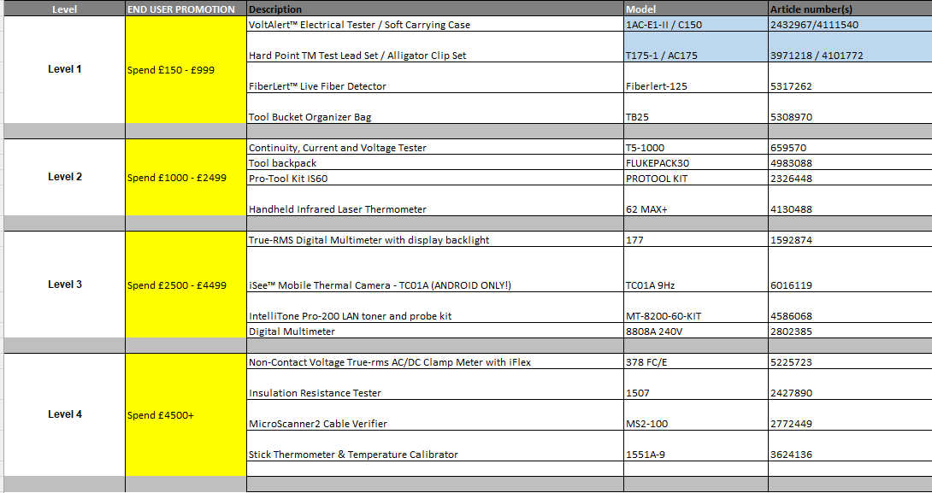
Fluke reserves the right to substitute the selected gift with a suitable alternative item of equal value (to be determined by Sponsor in its absolute discretion), if the originally selected Gift becomes unavailable or is subject to extended delivery times. Customers will be duly notified of any such change.

  - Register a claim via the Promotion’s online registration form at www.fluke.co.uk/freegift .The Promotion form must be fully completed and submitted along with a clear, legible scan of the invoice featuring at least one (1) Qualifying Purchase purchased during the Program Period, as proof of purchase. Packing slips, purchase orders/order confirmations are not acceptable as proof of purchase. Invoices with dates outside the Program Period are not valid and will not be considered. In addition to the proof of purchase, the customer’s address will be required to obtain the Gift.

  - Customers will be required to select their choice of Gift in the online registration form, based on the Level of amount corresponding to their invoice.

  - Note that invoices cannot be aggregated or used more than once. Where invoices have other products listed on them, in addition to the Qualifying Purchase(s), only the amounts pertaining to the Qualifying Purchase on such invoices will be considered while evaluating the eligibility of the Gift.

  - Sponsor will accept valid claims until August 31, 2025 (“Claims Deadline”). Claims registered after this date will be rejected as invalid.

  - Sponsor or its agents shall verify the submitted claims along with the provided invoice scans. In case of discrepancies in the form, Sponsor shall, at its sole discretion, be entitled to determine that customer’s eligibility of receiving the Gift. If Sponsor determines that the customer’s claim does not meet these terms and conditions or is otherwise ineligible, the customer will be informed accordingly.

  - Within 60-75 days from the Claims Deadline, Sponsor or its representatives shall dispatch the Gift to the address provided by the customer.

  - In case of non-receipt of the Gift, customer should inform Sponsor at the earliest, but no later than September 30, 2025. Claims of non-receipt received after this date shall be resolved solely at Sponsor’s sole discretion.

Gifts must be shipped to a customer’s physical address. Gifts cannot be shipped to post office boxes, reshipping companies or distributors. Gift requests are subject to further audit at Sponsor’s sole discretion, and if fraud or any failure to conform with these terms and conditions is identified by Sponsor, Sponsor in its sole discretion may render that Gift request void, in which case it will not be honored. Sponsor may require customers to provide additional proof of purchase, including, without limitation, physical carrier codes from packaging, product serial numbers, or proof of delivery.

The Gift will ship separately from the Qualifying Purchase. The Qualifying Purchase will be shipped by the authorised distributor from whom it was purchased.

This Promotion is a standalone promotion, and is not valid in conjunction with other any other promotions, offers, discounts or vouchers. The Gift cannot be offset against other services or purchases or combined with any special offers, promotions or contracts.

- Disclaimer. Sponsor and each of its parent companies, subsidiaries, and affiliates, and their respective directors, officers, professional advisors, representatives, employees and agents (collectively, the “Released Parties”) will not be responsible or have any liability for: (a) any late, lost, misrouted, garbled or distorted or damaged transmissions or purchase requests; (b) telephone, electronic, hardware, software, network, Internet, or other computer- or communications-related malfunctions or failures beyond Sponsor or the Released Parties reasonable control; (c) any Promotion disruptions, injuries, losses or damages caused by events beyond the reasonable control of Sponsor or by non-authorized human intervention; or (d) any printing or typographical errors in any materials associated with the Promotion.

- Release of Liability; Indemnification. Except where otherwise prohibited by law, by participating in the Promotion, you release and agree to indemnify and hold harmless each Released Party from any liability, obligation, injury, claim, suit, action, cost, expense, loss or damage of any kind, including any tax liability or loss of opportunity, whether direct, indirect, special or consequential, that may be imposed on, asserted against or incurred by such Released Party that arise out of or relate in any way to this Promotion or the incentives offered thereunder, including, but not limited to, where arising out of or relating to the following: (a) any technical difficulties or equipment malfunction (whether or not under Sponsor’s control); (b) any misdelivery, theft, unauthorized access or third party interference; (c) any entry or request under the Promotion that is late, lost, altered, damaged or misdirected (whether or not after their receipt by Sponsor) beyond the reasonable control of Sponsor; (d) any damages due to the operation of a postal or courier service; (e) any tax liability incurred by participant; and (f) use or misuse of any discounted product or gift with purchase (except to the extent covered by any applicable product warranty).

- Intellectual Property Notice. The Promotion and all accompanying materials, including these terms and conditions, are copyright © 2025 by Fluke Europe B.V. All rights reserved.

- Miscellaneous. The Promotion and these terms and conditions will be governed, construed and interpreted under the laws of the country of incorporation of Sponsor without applying any conflicts or choice of law provisions under such law that might refer the interpretation or any term thereof to the laws of any other jurisdiction. Customers participating in this Promotion are bound by these terms and conditions and by the decisions of Sponsor, which are final and binding in all respects. These terms and conditions constitute the entire agreement governing the Promotion and binding the customer, and no other agreement, verbal or otherwise, shall be binding regarding the Promotion unless it is in writing and signed by Sponsor. In case of any conflict or inconsistency between any other documents relating to the Promotion and these terms and conditions, these terms and conditions shall prevail. To the maximum extent provided by law, no waiver of any provision of these terms and conditions will be implied from any course of dealings between the customer and Sponsor or from any failure by the customer or Sponsor to assert its rights hereunder on any occasion or a series of occasions. To the fullest extent permitted by applicable law, Sponsor reserves the right to change these terms and conditions at any time, in its sole discretion, and to suspend or cancel the Promotion or any person’s participation in the Promotion should computer viruses, unauthorized human intervention or other causes beyond Sponsor’s reasonable control affect the administration, security or conduct of the Promotion, or Sponsor otherwise becomes (as determined in its sole discretion) incapable of conducting the Promotion as planned, or for any other reason determined by Sponsor to be appropriate in its discretion. Participants who violate these terms and conditions, violate any law, rule or regulation in connection with participation in the Promotion, tamper with the operation of the Promotion or any controller(s) offered hereunder, or engage in any conduct that is detrimental or unfair to Sponsor, the Promotion or any other participant (in each case as determined in Sponsor’s sole discretion) are subject to disqualification from participation in the Promotion. If you have any questions about these terms and conditions or the Promotion, please send an email to ehv-marcom@fluke.nl or send written questions to the following address: Fluke Europe B.V., BIC 1, 5657 BX, Eindhoven, the Netherlands.

- Sponsor’s use of the customer’s personal information provided to Sponsor is subject to Sponsor's Privacy Policy (available at http://en-us.fluke.com/site/privacy). If you have any questions about these terms and conditions or the Promotion, please email them to privacypolicy@fluke.com or send written questions to the address provided above.

